**Lecture 6 – Whiteboard notes**

## Linear Algebra basics – Inner product

$Input space: X= R^{d}= (X^{1},X^{2}, … X^{d})$

$Target space: y = \{ +1, -1\}$

$Classifier f: x-> y$

u and v are two points in the input space**.** u+ v and u-v are represented in the figure below.

u + v

ƛv

w

c

v

u

u - v

w = u – v (Orange arrows)

c = ½ (u + v)

$$<u, v> = : X * X -> R$$

If d = 2, then $u = [ u_{1}, u_{2}]$ and $v = [v_{1},v_{2}]$

$Inner product: <u, v> =$ $u_{1} v_{1}+ u_{2} v_{2}$

$$Norm of vector \left\|u\right\|= \sqrt{<u_{1}, u_{2}> }= \sqrt{{u_{1}}^{2}+ {u_{2} }^{2}}$$

v (0,1)

u (1,0)

$$<u, v> = u_{1} v_{1}+ u_{2} v_{2}=\left(1*0\right)+\left(1*0\right)=0$$

v (0,1)

u (1, -1)

$$<u, v> = u_{1} v_{1}+ u_{2} v_{2}=\left(1*0\right)+\left(-1*1\right)= -1$$

$$<u- v, e> >0, Same direction$$

$$<u- v, e> <0, Opposite direction$$

## Classifying a new point X

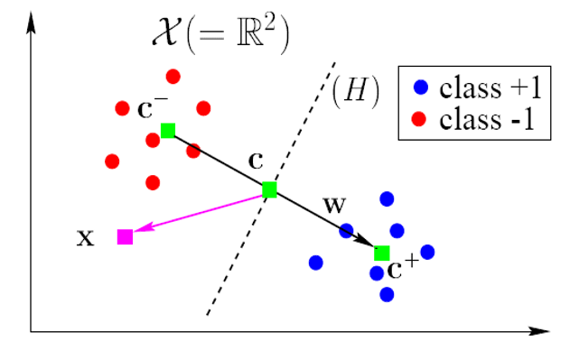

$$c^{+}= \frac{1}{n^{+}}\sum_{\{i:y_{i}=+1\}}{X_{i}}$$

$$c^{-}= \frac{1}{n^{-}}\sum_{\{i:y_{i}=-1\}}{X_{i}}$$

$$c=\frac{1}{2}(c^{+}+ c^{-})$$

$$w= c^{+}- c^{-}$$

A new point x to be classified,

$$h(x) = < w, x-c)$$

$$f(x) = sign(h(x))$$

$$h(x) = < w, x-c)= <w,x> - <w,c>$$

Substituting the value for w

$$h(x)= <c^{+}, x> - <c^{-}, x> - <c^{+}, c> + <c^{-}, c>$$

Substituting the value for $c^{+} and c^{-}$

$$h(x)= \frac{1}{n^{+}}\sum_{\{i:y_{i}=+1\}}{{<X}_{i},x> - } \frac{1}{n^{-}}\sum_{\{i:y_{i}=-1\}}{{<X}_{i},x> - <c^{+}, c> + <c^{-}, c>}$$

$$h\left(x\right)=\sum_{i=1}^{n}{∝_{i}}{<X}_{i},x> + b$$

$$∝_{i}=\frac{y_{i}}{n^{y_{i}}}$$

$$b= <c^{+}, c> + <c^{-}, c>$$

## Kernel Trick

* Transforming the data which is not linearly separable to a linearly separable space using a transformation $ϕ$

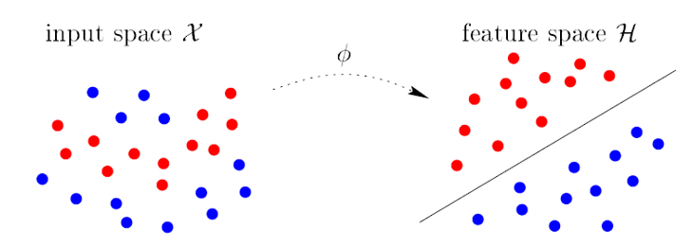

Each point x in the new transformed space is given by $ϕ$ (x)

A given pair of (x, y) is transformed into ( $ϕ$ (x), y)

X = Input space

Φ(X) = Feature space

$$h\left(x\right)=\sum_{i=1}^{n}{∝_{i}}{<ϕ(X}_{i}),ϕ(X)> + b$$

$$h\left(x\right)=\sum_{i=1}^{n}{∝_{i}}K\left(X_{i}, X\right)+ b, where K\left(X_{i}, X\right)= {<ϕ(X}_{i}),ϕ(X)>$$

$$K\left(X_{i}, X\right)=Kernel function$$

$$K\left(X_{i}, X\right)={[<u, v>+c]}^{d}$$

## Polynomial Kernel of degree 2

$$If d =2, and c = 0$$

$$K\left(X_{i}, X\right)={\left[<u, v>\right]}^{2}$$

$$K\left(X_{i}, X\right)={[ u_{1} v_{1}+ u_{2} v_{2}]}^{2}$$

$$K\left(X_{i}, X\right)={u_{1}}^{2}{v_{1}}^{2}+ {u_{2}}^{2}{v_{2}}^{2}+2u_{1} v_{1}u_{2} v_{2}$$

$$K\left(X_{i}, X\right)={u_{1}}^{2}{v_{1}}^{2}+ {u_{2}}^{2}{v_{2}}^{2}+\sqrt{2}u_{1}u_{2}\sqrt{2}v_{1}v_{2}$$

$$K\left(X_{i}, X\right)=\left({u_{1}}^{2}, \sqrt{2}u_{1}u_{2}, {u_{2}}^{2}\right){{, ({v_{1}}^{2}, \sqrt{2}v_{1}v_{2}, v}_{2}}^{2})$$

$$ϕ\left(u\right)= \left({u_{1}}^{2}, \sqrt{2}u_{1}u_{2}, {u_{2}}^{2}\right)$$

$$ϕ\left(v\right)={{, ({v_{1}}^{2}, \sqrt{2}v_{1}v_{2}, v}_{2}}^{2})$$

The input points have been transformed using kernel function